Running API Benchmark using Apache Bench (AB)

## What is AB?

Take a look at <https://www.petefreitag.com/item/689.cfm>

“If you have access to a Mac or Linux server, chances are you may already have **a really simple http load generating tool installed called Apache Bench, or ab**. If you are on windows and have Apache installed, you may also have ab.exe in your apache/bin folder.”

## How to use AB for benchmarking your API?

### Single Request:

Take the following example of running a very basic API load test using 100 requests for API hosted on port 3000 of localhost:



**Reading the output**:

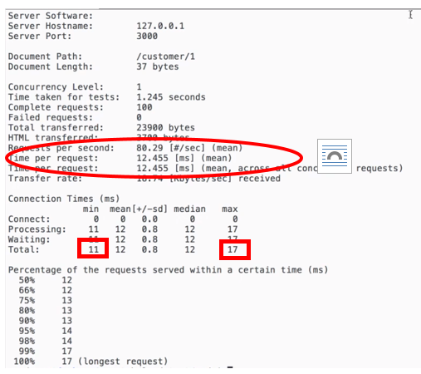

In the console output above, among others, “Requests per second” gives the mean capacity of API server to handle the requests. “Time per request” is more for API’s code performance in single user or concurrent user request scenarios.

Also, the table shows that quickest response took 11 ms while longest one took 17 ms time to complete.

**Redirecting the output to a file:**

ab -n 100 -c 10 http://127.0.0.1:3000/customer/1 > testResult.txt

The output of above command will be redirected to **testResult.txt** file.

**Concurrent use scenario:**

Continuing with previous test command, use –c switch for concurrency. In example below, it is being used for 100 requests for 10 concurrent users’ scenario:

ab -n 100 -c 10 http://127.0.0.1:3000/customer/1

## Multiple Request:

ab -n 100 -c 10 http://127.0.0.1:3000/customer/1 > testResult.txt &

ab -n 100 -c 10 http://127.0.0.1:3001/customer/1 > testResult1.txt &

The “**&**” separates the each command from another and allows to keep running the commands in parallel in background

Alternative: following command line also allows to run multiple requests in parallel:



Pay attention to | and *parallel –j* switch to the command. It’s processing 1000 requests.